**From:** Soh, Ivy   
**Sent:** Monday, 05 February, 2018 10:46 AM  
**To:** Chan, Pei-Fong  
**Cc:** Ng, Xiang Yue; Ng, Crystal; Chan, Kim Lan; Tan, Yan Zhang  
**Subject:** Auto Trigger Report - Month-end Current Report (Amazon)

Hi Pei Fong,

Can we have an auto trigger month end Inventory Balance report, at 2359hrs of every last day of the month.

Starting from Feb18 onwards.

Send to:

[Ivy.soh@dbschenker.com](mailto:Ivy.soh@dbschenker.com)

[Yan-Zhang.Tan@dbschenker.com](mailto:Yan-Zhang.Tan@dbschenker.com)

[hui-fen.ng@dbschenker.com](mailto:hui-fen.ng@dbschenker.com)

[Xiang-Yue.Ng@dbschenker.com](mailto:Xiang-Yue.Ng@dbschenker.com)

[Kim-Lan.Chan@dbschenker.com](mailto:Kim-Lan.Chan@dbschenker.com)

Regards  
  
Ivy Soh  
Direct Line: (65) 6549-1136  
H/P: (65) 9177-1233  
Email: [ivy.soh@dbschenker.com](mailto:ivy.soh@dbschenker.com)

Updated:

2018.02.12

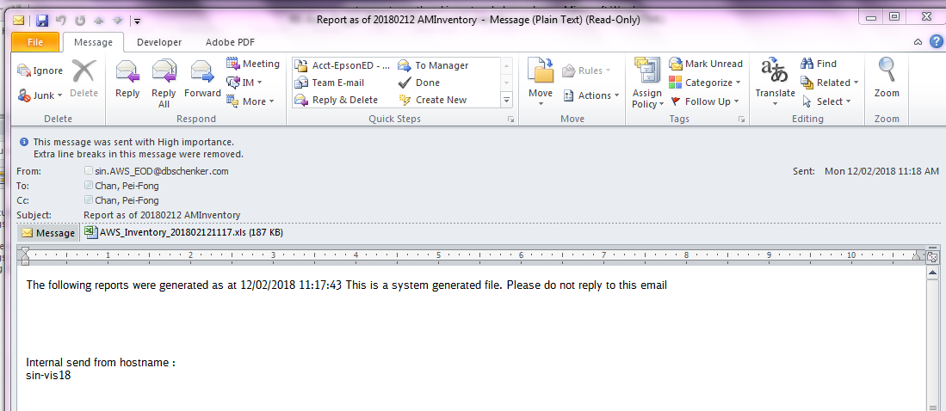

EOD setup in SIN-VIS18

\\sin-vis18\SINIT\AMAZON\EOD

